

*Note: your unique exhibitor promo code will be emailed to you. If you cannot locate your promo code, please email mmelsop@iwcs.org.
Access the event logo, graphics, and easily customizable templates at https://iwcs.org/exhibitor-promotional-graphics/.

Suggested Image and Text to Use In Email to Customers and Business Partners:
Subject: Complimentary Invitation for the IWCS Cable & Connectivity Industry Forum
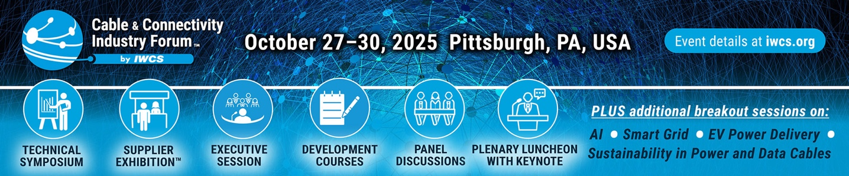
Join [insert your company name] at the upcoming IWCS Cable & Connectivity Industry Forum, taking place October 27–30 in Pittsburgh, Pennsylvania, USA. We will be participating alongside other industry leaders during the Supplier Exhibition on Tuesday, October 28 and Wednesday, October 29. Experience the Supplier Exhibition free of charge by entering the promo code [insert your unique exhibitor promo code] when you register online at iwcs.org/register.
You may choose to upgrade your pass to access to the additional event components such as the Technical Symposium, (New) Topical Trend Sessions, Plenary Luncheon with Keynote, Executive Session, or Professional Development Courses. New this year, IWCS is offering auxiliary trend components that are divided into four special sessions featuring discussions on the following topics: artificial intelligence + machine learning, sustainable solutions for power and data cables, smart grid infrastructure, and cable innovations for automotive and electric vehicles. Don’t miss this premier event for new technologies in the cable and connectivity industry!
We hope to see you in Pittsburgh. Be sure to visit us at booth # [insert your booth number] !

