

*Note: your unique exhibitor promo code will be emailed to you. If you cannot locate your promo code, please email mmelsop@iwcs.org.
Access the event logo, graphics, and easily customizable templates at https://iwcs.org/exhibitor-promotional-graphics/.

Social Media Post Template:
Join us October 28–29 when we will be hosting a Supplier Exhibition™ booth at the @IWCS – The Cable & Connectivity Industry Forum in Pittsburgh, Pennsylvania, USA. Stop by booth # [insert your booth number] to discover [brief description of what you will exhibit].
In addition to the Supplier Exhibition, the #IWCS2025 Forum includes a Technical Symposium featuring previously unpublished Technical Papers, Topical Trend Sessions, Plenary Luncheon with influential Keynote Speaker, Executive Session, Professional Development Courses, and more. Visit https://iwcs.org to learn more and register to attend the premier event for new technologies in the cable and connectivity industry. As our guest, you receive complimentary access to the Supplier Exhibition by entering promo code [insert your unique exhibitor promo code] when you register.
Social media image
option #1:
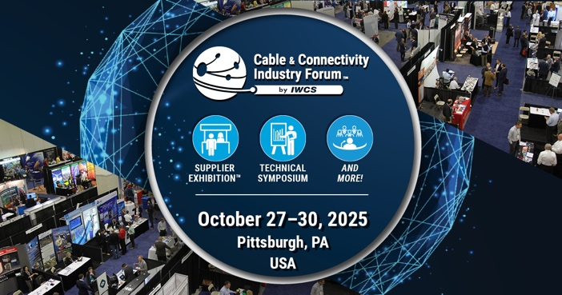
Social media image
option #2:
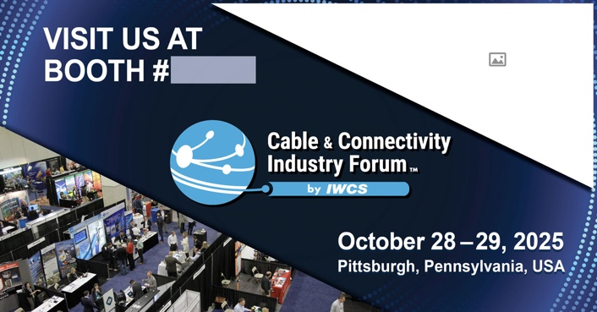
Easily upload your logo and type your booth #
IWCS Tags for social media:
#IWCS2025
Facebook: @IWCScable
Twitter: @IWCScable
LinkedIn: @IWCS - The International Cable & Connectivity Symposium
Website: https://iwcs.org

